Experiment 4

PENDULUM OSCILLATION WITH pc INTERFACE

Principle and task

Earth’s gravitational acceleration g is determined for different lengths of the pendulum by means of the oscillating period. If the oscillating plane of the pendulum is not parallel to the gravitational field of the earth, only one component of the gravitational force acts on the pendulum movement.

I. background

As a good approximation, the pendulum used here can be treated as a mathematical (simple) pendulum having mass m and a length l. When pendulum mass m is deviated to a small angle γ, a retracting force acts on it to the initial blanced position (Fig.1):  F(γ) = – mg · sinγ ≈ – mg.γ (1)  If one ensures that the amplitudes remain sufficiently small while experimenting, the movement can be described by the following differential equation:  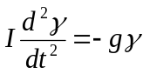 (2)  The solution of eq.(2) can be written as follows: | 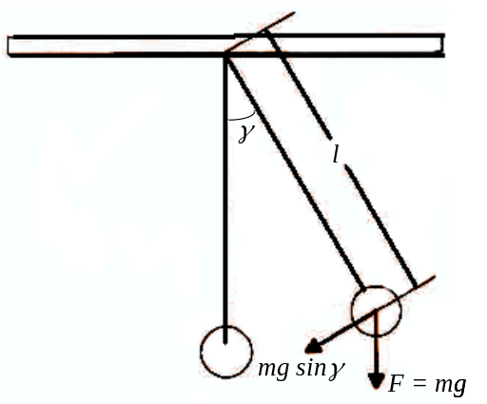  Fig. 1. Pendulum with vertical  oscillation plane
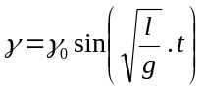 (3)
This is a harmonic oscillation having the amplitude γ₀ and the oscillation period T.
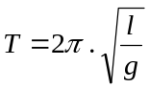 (4)
However, for greater amplitudes this equation must be replaced by an expression such as:
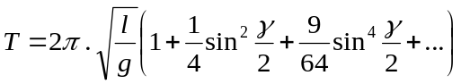 (5)
If one rotates the oscillation plane around the angle θ with respect to the vertical plane as shown in Fig.2, the components of the acceleration of gravity g(θ) which are effective in its oscillation plane are reduced to g(θ) = g. cosθ, that is only the force component mg.sinγ .cosθ is effective and the following is obtained for the oscillation period:  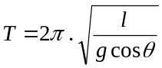 (6) | 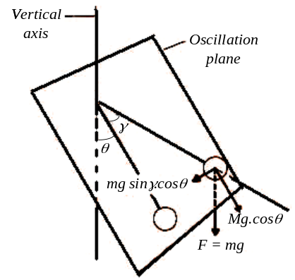  Fig. 2. Pendulum with inclined  oscillation plane
II. experimental procedure
1.Set-up

- The oscillating periods of the thread pendulum are measured according to Fig. 3.

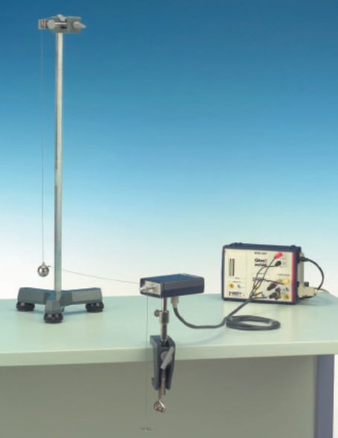  Fig. 3. Experimental set-up for the determination g from the oscillation period | 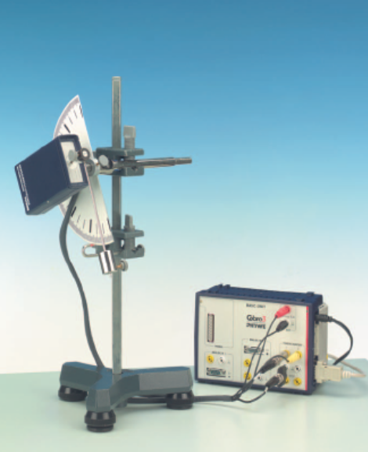  Fig. 4. Experimental set-up  for the variable g pendulum

- Fig.4 shows the set up to carry out measurements with the variable g pendulum.
- The electric connection of the movement recorder is carried out according to Fig. 6 for the COBRA interface (Fig.5). The thread runs horizontally and is lead past the larger of the two thread grooves of the movement recorder.

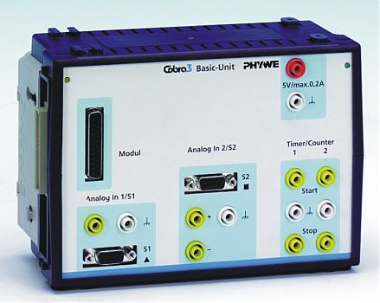  Fig. 5. COBRA3 Interface | 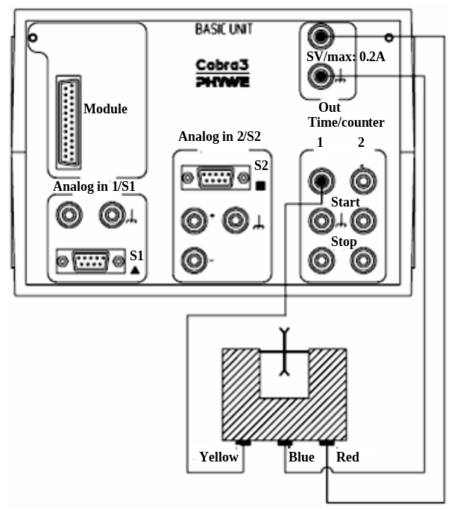  Fig. 6. Electric connections
2. Preparations

- COBRA: if the COBRA interface is connected to the computer port COM1 “Osc_COM1” is clicked on twice. If the serial port COM 2 is used “Osc. COM 2” is started.
- The maximum sampling rate <Delta t/ms> is adjusted according to computer speed. Sampling time is set by shifting the grey slide with the mouse cursor. Modification of <Delta t/ms> must be repeated every time the programme is started. A too short sampling time is identified through the following effects:
- No measurement values are recorded.
- The measurement values are not equidistant on the time axis.
- The distance in time of the measurement points is much larger than the set <Delta t/ms> value.

3. Experimental procedure

- Set up the experiment according to Fig. 3. The oscillating plane runs vertically to start with. A box bubble level set on the casing of the movement recorder facilitates exact adjustment.
- Set the measuring parameters on COBRA window according to Fig. 7. The diameter of the thread groove of the movement recorder is entered into the input window d₀ (12 mm are set as a default value). In the first part of the experiment (thread pendulum), d₁ is the double length of the pendulum in mm, that is, the diameter of the circle described by the centre of gravity of the pendulum. In this case, the measured deviations of the pendulum sphere are indicated directly in rad. If measurements are carried out with the g pendulum, 12 is entered for d₁ (d₁ = d₀), because the pendulum is now coupled 1:1 with the movement measuring unit. Each of these entries must be confirmed with the “Return” key on the keyboard.

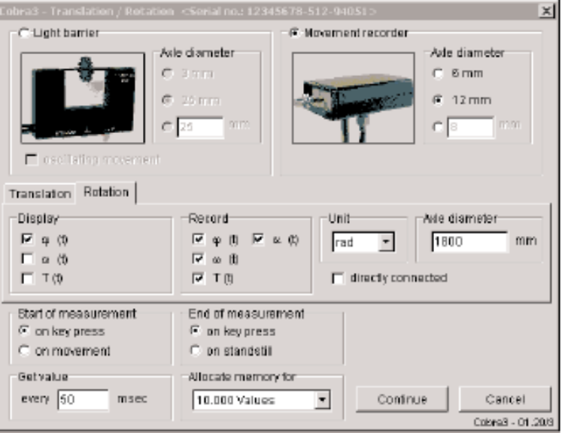

Fig. 7. Measurement parameter box

- Move the 1-g weight holder, which tenses the coupling thread between the pendulum sphere and the movement sensor, manually downward and the release it. This avoids lateral oscillations of the pendulum ball, which can lead to measurement errors. If the values (50 ms) in the ”Get value every (50) ms” dialog box are too high or too low, noisy or non-uniform measurements can occur. In this case adjust the measurement sampling rate appropriately. The <Start> button must then be pressed. A new measurement can be initiated any time with the <Reset> button, the number of measurement points “n” is reset to zero. In total, about n = 250 measurement values are recorded and then the <Stop> button is pressed.
- Now the newly appearing <Edit> button is pressed. After a few seconds, three new order buttons appear on the screen. Click on the <Edit> button. The vertical lines can be captured and shifted with the mouse button. They are positioned in such a way that all measurement values which are to be evaluated lie between the two lines. The <Edit> button is pressed again, followed by the <Evaluate> button. The computer now needs some time to evaluate all
data, the length of which depends on the number of measurement points. The process is indicated by a counter running backwards.
- After the evaluation, a graph similar to Fig. 8 appears on the screen. The duration of the period T and the circular frequency v(w) of the oscillation are displayed. Press button <g>. To calculate Earth’s gravitational acceleration g, the actual numerical value is entered into the input field for pendulum length l In this experiment, the numerical values for “theta” are meaningless. Earth’s gravitational acceleration is calculated for different pendulum lengths but constant pendulum mass. Then the mass of the pendulum is increased by suspending the second sphere from the eye of the first, keeping the length of the pendulum constant, and g is determined.

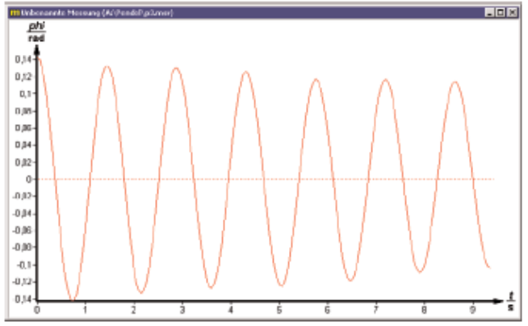
Fig. 8. Typical pendulum oscillation

- Subsequently, keep the pendulum length constant but increase the pendulum mass by hanging the second sphere onto the eyelet of the first one; and then determine g. Determine the period duration with the aid of the cursor lines, which can be freely moved and shifted onto the adjacent maxima or minima of the oscillation curve (Fig. 9).

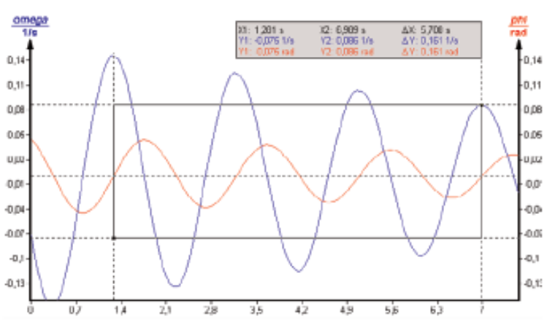
Fig. 9. Typical measurement result
- Rebuild the experimental set-up according to Fig. 4. The oscillation plane is initially vertical. The round level located on top of the movement sensor housing facilitates the exact adjustment. Determine g for various deflection angles. For identical initial deflection angles (e.g. approx. γ = 15°) determine g; in these measurements, however, the oscillation plane is not vertical but rather at an angle θ to the perpendicular. The following angles are recommended for measurement:: θ = 0°,10°, 20°, 40°, 60°, 80°.

III. PROCESSING OF experimental DATA

1. Determination of the oscillation period of a thread pendulum as a function of the pendulum length.
2. Determination of g.
3. Determination of the gravitational acceleration as a function of the inclination of the pendulum force.

